**TM4 BIT695**

**Michael Croft**

**4300099**

**Task 1**

(a)

In the Case study provided for TM1 we must look at the site before any changes were made. There are however forms that work in a static website. With the availability of this site. Someone could easily change the code to see active cookies and potentially gain access to impersonate or steal valuable information about a user. Looking at penetration testing it is clear to see that the case study is flawed in many ways. This is basically tested with ethical hacking to determine what the issues are. If you don’t pass this then your site has very bad issues. Her the case study would fail. Source code review checks are the process of checking source code manually. When looking at the case study there are no backdoors but there is also no security checks to catch tampering. The source code has weakness in cryptography and flawed logic. This to me would also be a fail. Manual inspections and reviews are conducted to check the processes and the developers themselves. This can be the most effective technique as humans are used to pick up the issues. This can be time consuming and requires humans for the task at hand. The security on the case study is minimal. But by the lack of supporting files such as logins and submission forms. This means attacks from SQL whereas injection attacks are impossible. Other injections are possible though such as script and html. Most of the flaws for security are in the html file from template. The data can be Passed here such as passwords, Names, surnames and email addresses this is enough to gain information on others. Looking at these issues it is clear that there are major concerns around the security of the case study and also that most of the issues are cantered on the forms.html. I would fail this website on all forms of security testing I have mentioned and would illustrate the importance of cleaning this up.

(b)

The CIA Triad is a model with three main goals

1. Confidentiality
2. Integrity
3. Availability

These are the Main factors around internet security and the most basic. When looking at The CIA Triad in terms of availability with e commerce the main importance is on ease of access with so many individuals shopping, conducting business and carrying out other transactions online. This must have all aspects of the system working properly to ensure the availability is maintained. Adequate and accurate bandwidth must be maintained always as accessibility can be compromised if these requirements are not met. Availability is the most important goals for the CIA triad model as without it e commerce could not operate. The Impact of this an come in confidentiality as information security can be compromised if too much availability is granted this provides are very interesting conflict as two of the three goals of the CIA model can impact each other.

The Limitations of the CIA model mostly are concerned with data. Big Data can cause issues this poses extreme challenges around the share volume of information. Creating duplicate data or Data recovery plans must be looked at. The issues with this are the expense and time that the process can take. With the amount of data responsible data oversight can lack and cause major issued. This was exposed by Edward Snowden and brought to international attention for which he is now seeking refuse in Russia. The issue is that data transmitted from a given endpoint may not cause any privacy issues but when fragmented and from multiple endpoints well this can be dangerous. The ability for information to be gathered, collected and analysed can yield major breaches in sensitive information. This issue can arise even with network breaches form a Wi-Fi enabled lightbulb, fridge or Washing machine. The information has to be kept secure and devices must be constantly updated to prevent the issues that arise.

**References**

<https://whatis.techtarget.com/definition/Confidentiality-integrity-and-availability-CIA>.

http://panmore.com/the-cia-triad-confidentiality-integrity-availability

**Task 2**

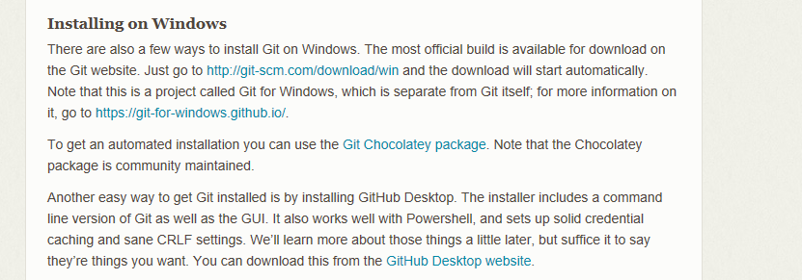

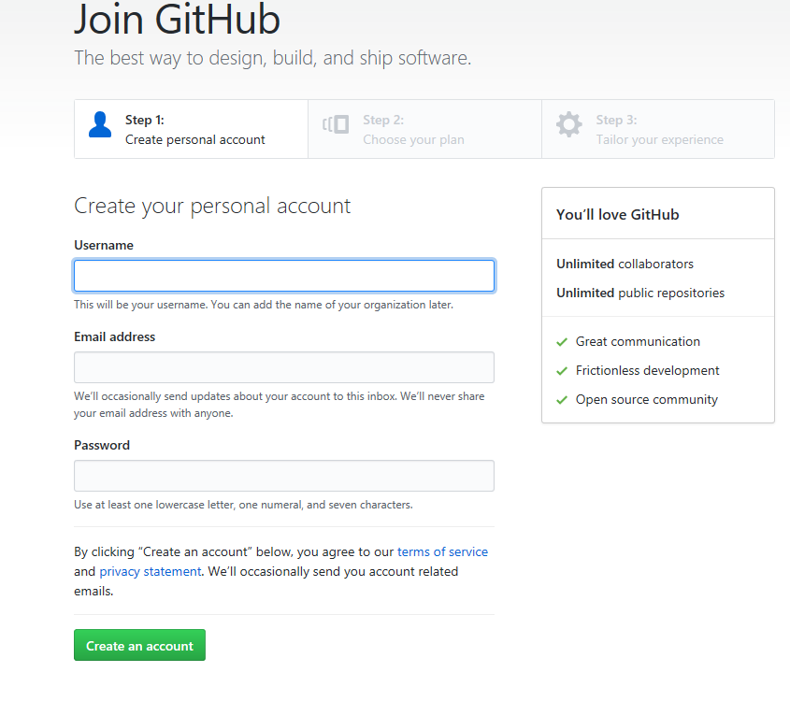

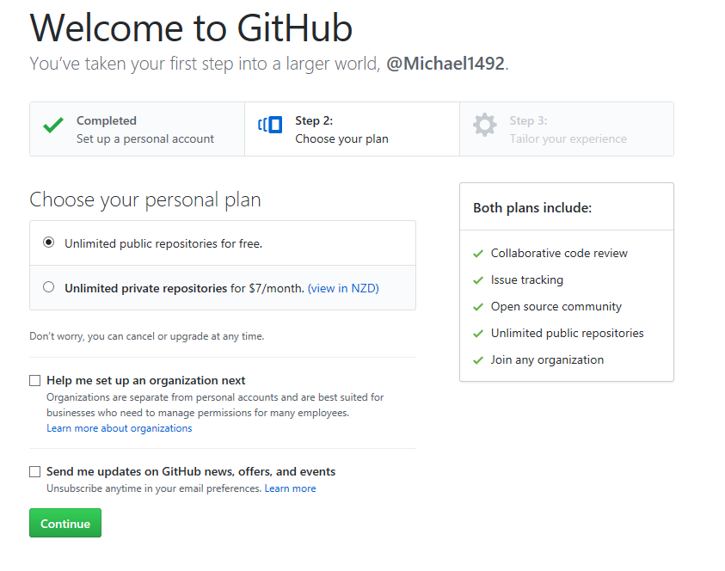

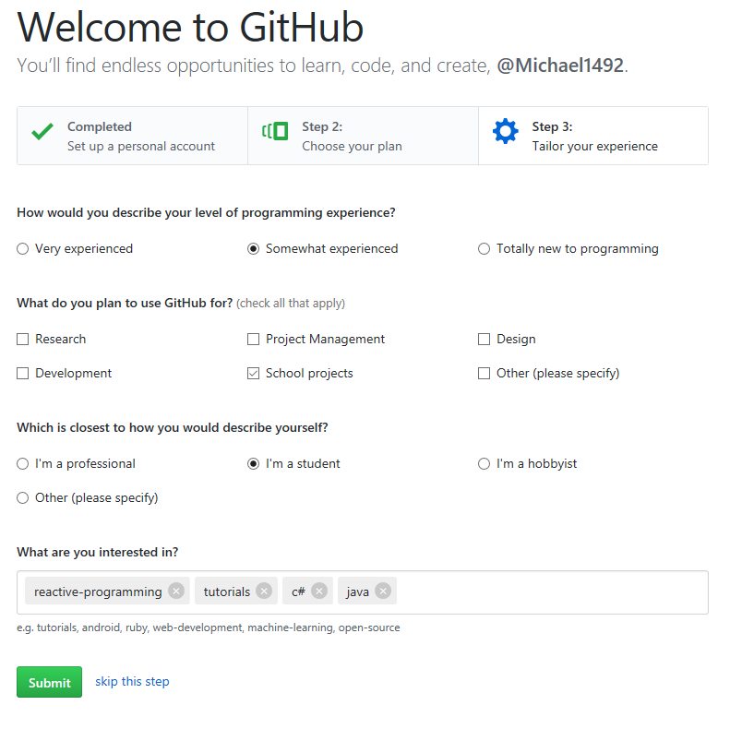

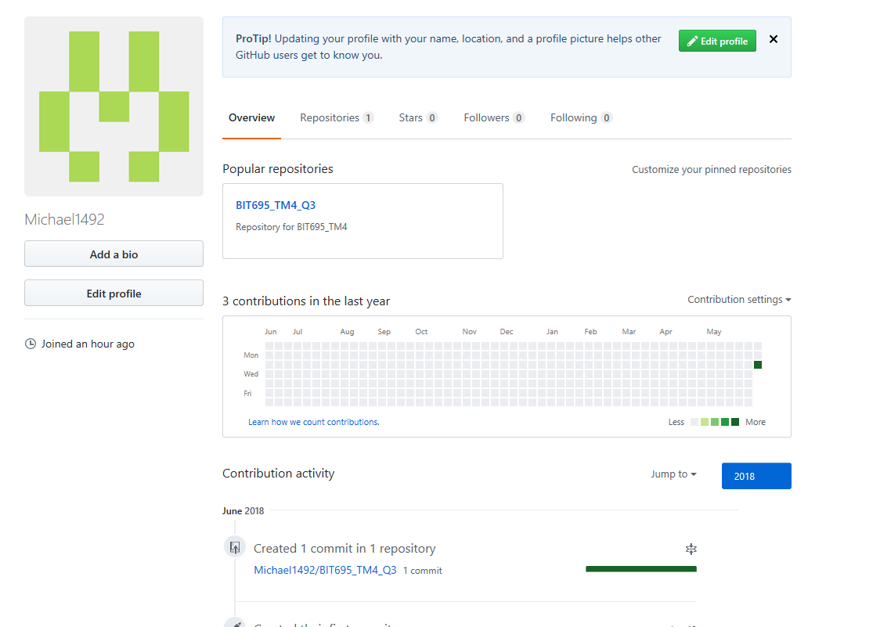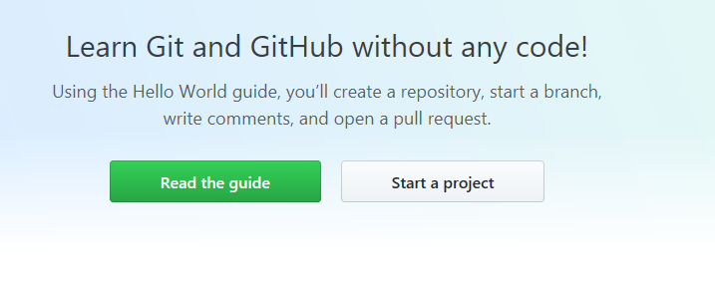

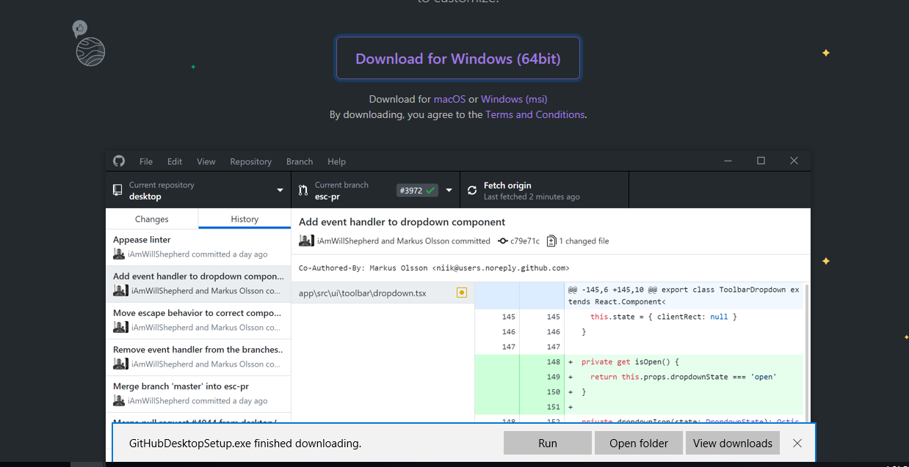

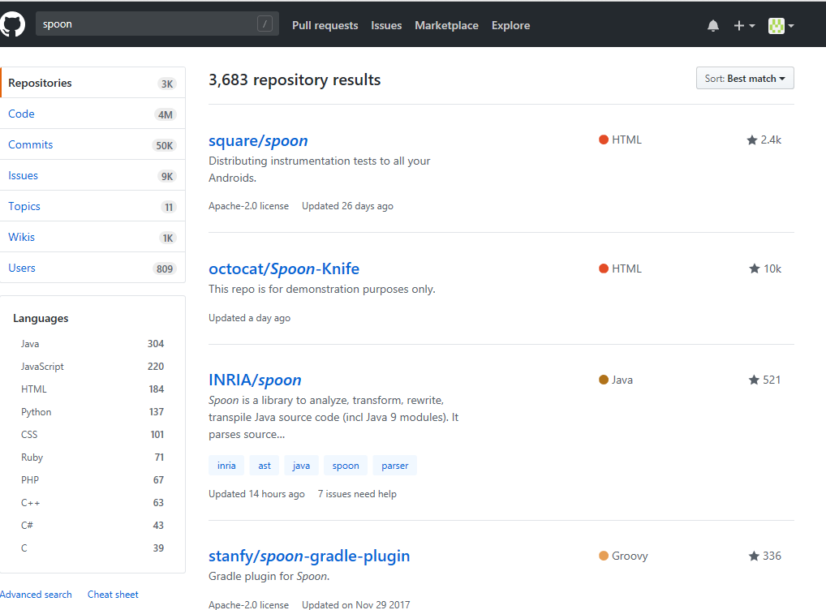

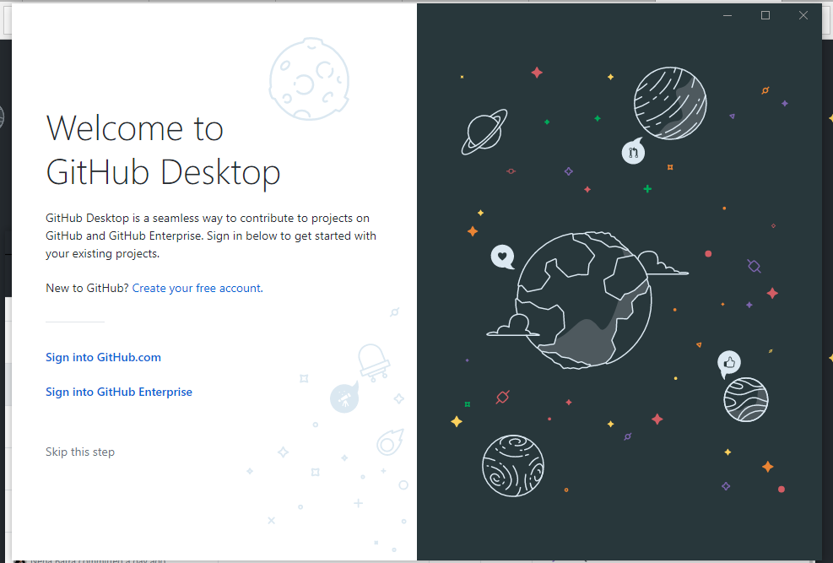

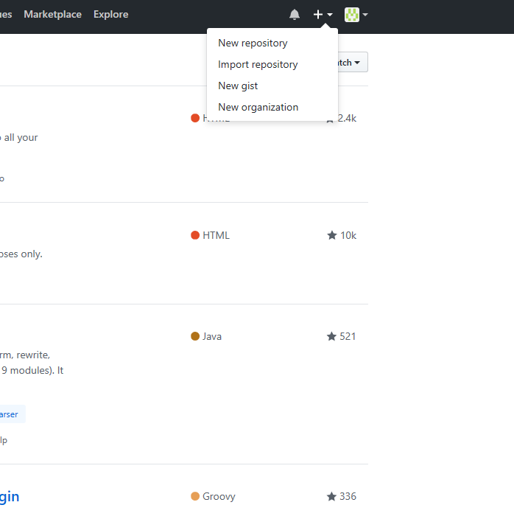

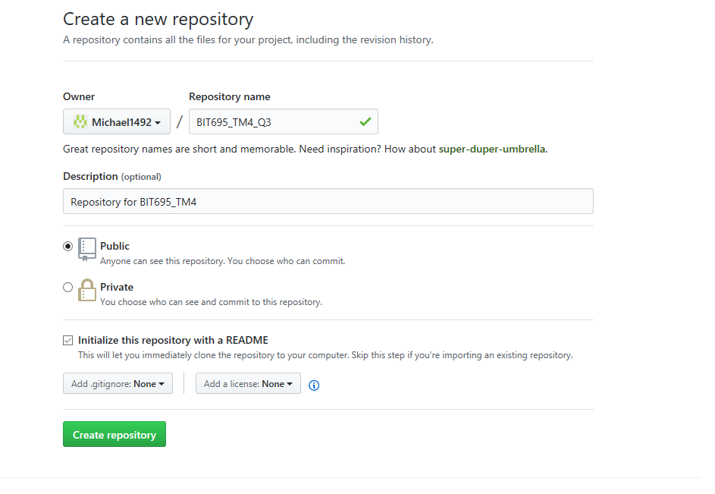

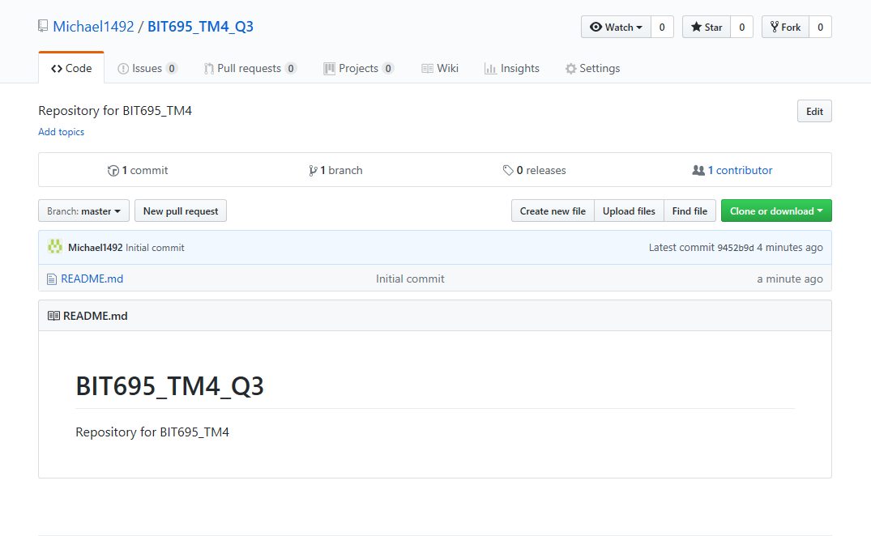

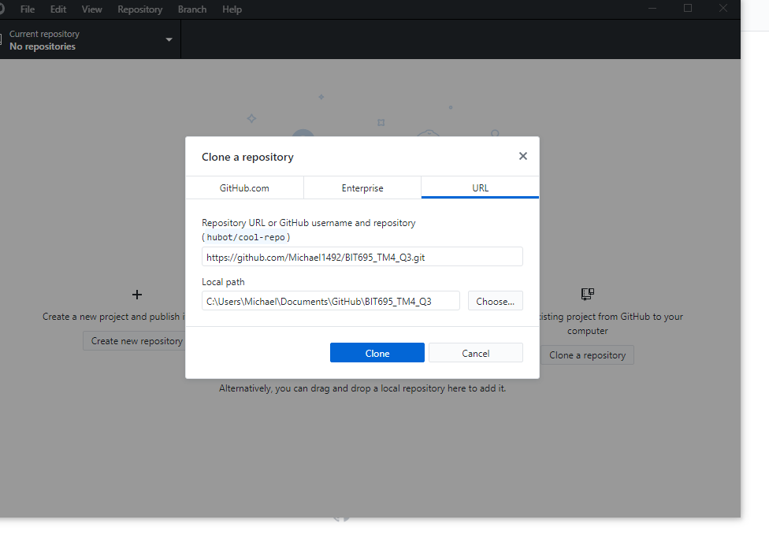

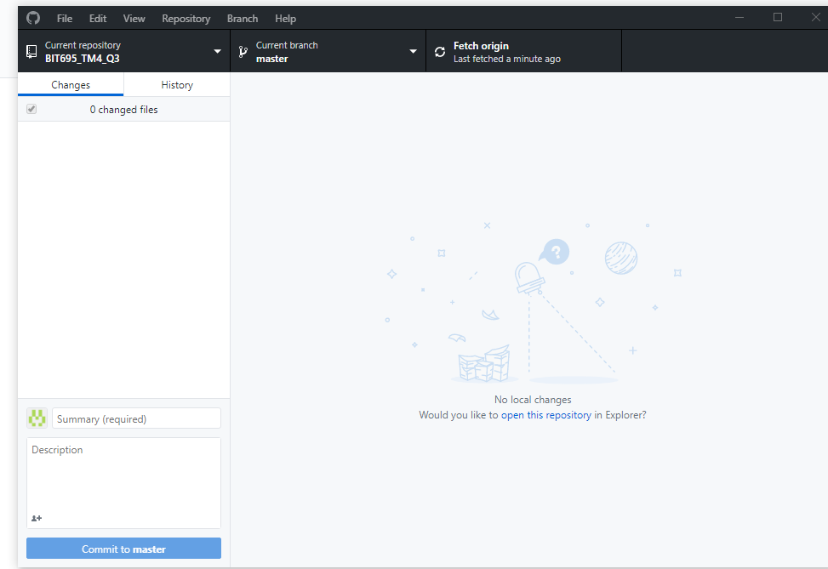

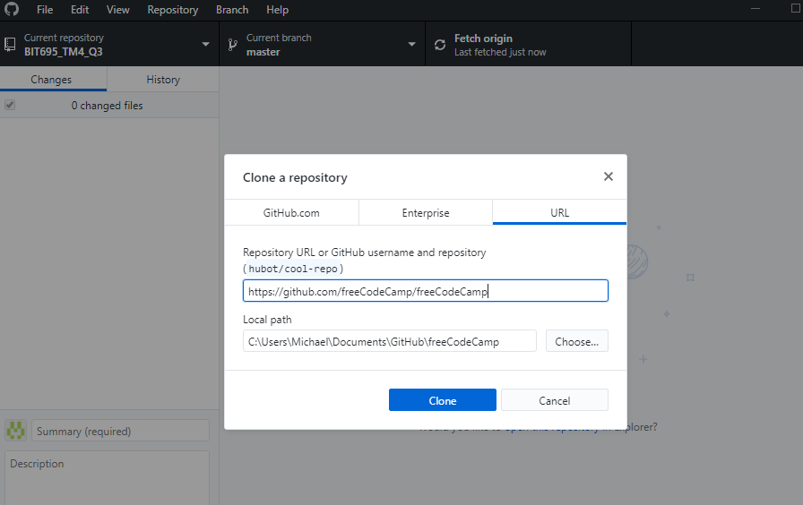

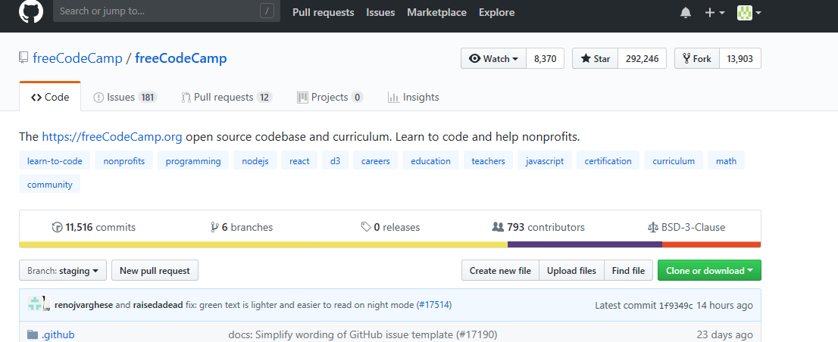

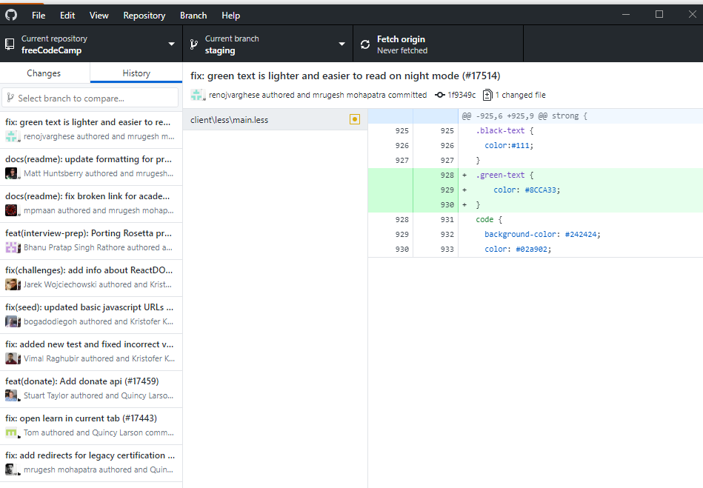

(c) Compare Github to BitBucket

|  |  |  |
| --- | --- | --- |
| **Feature** | **GitHub** | **Bitbucket** |
| Storage | Has unlimited storage but asks that repositories are less than 1 GB. Has a limit on files over 100MB also. | Free accounts are limited to 1GB soft and 2Gb hard limit. |
| Repositories | Free accounts must use Public repositories. Private Repositories are paid only. | Collaborate with 5 teammates on unlimited private repos for free. Checkout Standard ($2/user/mo) or Premium ($5/user/mo) as your team scales. |
| Wikis | Each wiki is its own repository. A text editor lets you add docs in the text formatting language of your choice. | Has a wiki feature for each repository can directly import mark down code. They can be public or private. |
| Boards/cards | Reference every Issue and Pull Request in a card, a drag-and-droppable snapshot of the work your teams do in your repository. | Trello's boards, lists and cards enable you to organize, prioritize and collaborate on your projects in a fast, flexible way. |
| Integration | Create your own tools with greater access to data than ever before using GraphQL APi—the same API we use to build GitHub. Uses Jira software. | Can build results from your CI system a pass or fail icon tells you about the health of your code. |
| Social Coding | Follow projects, explore interests and share your achievements. | Built for teams, can customise code, merge requirements and strategies. |
| Security | Make changes confidently, with the paid private repositories you can allow minimal access. | Provides workflow for all. Right access to code with fine grained permissions development workflows and audit logs. |
| Users | Unlimited for any account. | Maximum of 5 users for free repositories. Any more then it starts to cost. |
| Pull requests | Can pull requests with multiple commits. | Sets up forums for code to be discussed and altered with changes tracked. |
| Cost for more access and private repositories. ($US) Monthly. | * Micro, $7, 5 Private Repositories * Small, $12, 10 Private Repositories * Medium, $22, 20 Private Repositories * Bronze(Business), $25, 10 Private Repositories | * Max no of users 5, Free, Unlimited Repositories * Max no of users 10, $10, Unlimited Repositories * Max no of users 25, $25, Unlimited Repositories * Max no of users 50, $50, Unlimited Repositories |
|  |  |  |

Task 3

1. **Table 1**

|  |  |  |  |
| --- | --- | --- | --- |
| **Activity** | **Start date and time** | **Expected completion date and time** | **Notes or comments** |
| Planning | 15/06/18 at 9:30am | 15/06/18 at 12pm | Plan and review task. |
| Database update | 15/06/18 at 12pm | 15/06/18 at 2pm | Ensuring Database is there for assignment. |
| Coding for database and tables | 15/06/18 at 2:30pm | 16/06/18 at 5pm | Ensure tables are correct. |
| CRUD pages | 17/06/18 at 9am | 17/06/18 by 11:59 am | Test, Write and complete. |
| Submission | 17/06/18 at 9am | 17/06/18 by 11:59 am | Finalised and submit. |
| Contemplate | 18/06/18 | To when results are back. | Hope I have passed the course. |

**Table 2**

|  |  |  |  |
| --- | --- | --- | --- |
| **Risk event** | **Impact** | **Mitigation steps** | **Severity (1-5)** |
| Computer Issues | Loss of information, time and potential computer failure. | Back up files on external devices. Make sure devices are pugged in so battery doesn’t run out. | 4 - 5 |
| Loss of power. | Loss of information, time, and potential for devices to be damaged. | Make sure battery is full on devices, use mobile as a hotspot to use internet if possible. | 5 |
| Injury or Illness | Could be a long time to recover, could be fatal. | Well try to be safe but hard to really stop. | 3 |
| Other Courses | Could take more time than expected and eat into your time | Plan ahead, give yourself time and ask for help. Also ask for extensions if required | 2 |
| External influences. | Cat getting ill, partner in a bind. Could cause time to pass where you would normally be working. Working too. extra hours needed. | Plan ahead, some things are unforeseeable just plan for it. | 1-2 |